The Photo Manipulation from the Perspective of
Photographers: Study from Jordan

Amjad Omar Safori
asafori@zu.edu.jo
Ahmad Ananbey

Abstract
From both positive and negative perspectives, photo manipulation has an impact on all areas of photography. Although the effect of photo manipulation is a personal matter, the effect of its application is reflected in the type of audience that consumes the image. Therefore, the research aims to study photographers' understanding of image manipulation and its ethics, in addition to identifying image manipulation techniques from the photographers' professional point of view. A total of 228 responses were obtained using the online questionnaire. The results of the study indicate that photographers consider photo manipulation as one of the elements responsible for losing the credibility of photography and the image. However, the respondents agreed that unethical photo manipulation is an issue of increasing importance in the photography community, and they identified the need for ethical conduct in all genres of photography in order to reduce wrong practices. The results also show that manipulation techniques that do not harm the content of image are acceptable to photographers.
Keywords: Photographers, Photojournalism, Media Ethics, Impact of Photoshop, Photo Manipulation

التلاعب بالصور من منظور المصورين: دراسة من الأردن

أمجد عمر صفوري
احمد عنانبه

ملخص
من المنظورين الإيجابي والسلبي، فإن التلاعب بالصور له تأثير على جميع مجالات التصوير، فعلى الرغم من أن تأثير التلاعب بالصور يعد أمرا شخصيا، إلا تأثير تطبيقه ينعكس على نوع الجمهور الذي يستهلك الصورة. لذلك، يهدف البحث إلى دراسة فهم المصورين للتلاعب بالصور وأخلاقياتها، اضافة إلى التعرف على تقنيات التلاعب بالصور من وجهة النظر المهنية للمصورين. تم الحصول على ما مجموعه 228 استجابة باستخدام الاستبيان الالكتروني. تشير نتائج الدراسة إلى أن المصورين يعتبرون التلاعب بالصور من العناصر المسؤولة عن فقدان مصداقية التصوير والصورة، فيما اتفق المجيبون على أن التلاعب غير الأخلاقي بالصور هو قضية ذات أهمية متزايدة في مجتمع التصوير الفوتوغرافي، وحددوا الحاجة إلى اتباع السلوك الأخلاقي في جميع أنواع التصوير للحد من الممارسات الخاطئة. تظهر النتائج أيضا أن تقنيات التلاعب التي لا تضر بمحتوى الصورة مقبولة للمصورين.
الكلمات الدالة: المصورون الفوتوغرافيون، التصوير الصحفي، أخلاقيات الإعلام، تأثير الفوتوشوب، التلاعب بالصور.

Introduction:
Many novice photographers or users of social media try to imitate professional photographers' photographs, particularly those related to the aesthetics of nature and human life. As a consequence of trading their photos without referring to them, many professional photographers are exposed to the curtailment of their intellectual rights. This case raised a question for all the world's sensitive photographers: Where's the line between reality and manipulated reality?.
The crossing line of the ethical dilemma produced by digital photo manipulation is clearly defined by this situation. In the manipulation of a fashion or advertising photographer, is it justified to expect the same degree of ethical behaviour expected from a photojournalist? In defining when photo processing crosses a boundary into unethical manipulation, the issue arises. In different photography genres, photographers have different mindsets and ethical prejudices. The decision-making and attitude of the photographer towards photo manipulation are shaped by professional requisitions of their genre of photography (Sharma & Sharma, 2017). A fashion or advertisement photographer is far more tolerant for photoshop processing his images than a photojournalist. Other factors also play a big role in shaping their perception about photo manipulation, like photographers’ educational background, professional reputation, etc. The composition of the photo manipulation problem in photography can be understood by the application of various photoshop techniques. There are multiple techniques employed by photographers for processing images in photoshop. For example, colour correction, cropping, brightness-contrast, cloning, etc. The application of these techniques depends on the photography genre for which photograph is being rendered. Removing power lines using cloning from a landscape and removing people from a news photo cannot be judged on the equal ethical ground (Thompson, 2017; Roux, 2019). Yet, correction of colour can be justified in almost all situations unless it is not altering the truth. The moral dilemma related to photo manipulation ascends in the grey area between these extremes.
In the late 1970s, the trend began to rely on technology in photography, especially about reshaping the readers’ perception of reality. The digital development has led to an increase in cases of deception of the public and misinterpretation of information and facts, which led to lack of confidence in photographic materials and decrease in the credibility of photographers (Roux, 2019). Manipulating photos create visual transformations for photographers, using the digital revolution and photo-editing techniques, to make changes to photos at almost no cost. Image manipulation has threatened the lives of many photographers (Silva & Eldridge, 2020). The unethical manipulation of images to create quick, easy, and interesting graphic stories is costly to many photographers, and will ultimately lead to the loss of credibility of these stories (Safori, 2018).
There is a cross line between moral commitment and image manipulation. Many photographers face many problems with image manipulation as it raises viewers' expectations about the visual strength of photography, even though photographers do not use unethical changes in their work (Winslow, 2005). Many photographers who do not use photo-editing techniques feel intense competition from photo manipulators to gain popularity among audiences. Few photographers follow ethical rules in dealing with images, while others believe that it is morally and professionally acceptable to use some image processing techniques, like colour modification, cropping, and brightness contrast adjustment, provided that the content of the image is preserved and that the understanding of the audience is not played with (Winslow, 2005).
The objective of this research is two-fold. The first goal is to examine the perception of photographers about the impact of photo manipulation on photography and its ethics. This entails the following question: Is photo manipulation responsible for photography's loss of credibility? The second goal involves investigating the acceptability of multiple photo manipulation techniques, such as cropping, brightness-contrast, cloning, etc. To elicit answers to achieve these research goals, a web-based survey was administered. The filled-out survey was reported by around 230 respondents over two months. For the survey, this study selected photographers (experts and beginners) who make photoshop processing decisions in their professional life. The study is critical because it asks for the opinion of photographers on photo manipulation and its impact on their professional lives. As very few scholars have researched the view of photographers on this issue, this point makes this study pioneer and unusal.
The research aims to understand, on an ethical basis, the perception of photographers towards photo manipulation. The other aspect of this research provides an empirical ground for the acceptability of photo manipulation techniques in the professional ethics of photographers in their genre of photography.

Literature Review
In photo manipulation, discussion of ethical inquiry has been limited to two areas: i) investigating the opinion of the editor and ii) the perception of the reader. Studies have been carried out on the attitudes and tolerance of photo editors towards photo manipulation (Gladney, & Ehrlich, 1996), and the acceptance of image alteration in newspapers by readers, but there has always been a lack of research on the opinion of photographers on this issue. While the impact of photo manipulation on the credibility of photojournalism has been examined by some researchers, all of this literature has focused on the perspective of journalism (Silva & Eldridge, 2020; Mortensen & Gade, 2018). Academic research on photographers (experts and beginners), who are the real doers of digital alteration, is sparse. Reaves (1995) conducted several relevant studies on this issue by inquiring about digitally manipulated images in news media from editors and readers. She also examined the interrelationship between the demographic factors of photographers and their attitude to photo manipulation. Reaves (1995) argues that "(T)he attitudes of photo editors towards digital manipulation should be influenced by a background in photojournalism and exposure to the problems of photojournalism."
In its report, the Pew Research Centre for the People and the Press (1999) stated that the deterioration of credibility is a major concern for today's media. Ritchin stated that, with increasing cases of manipulated images, photojournalists are responsible for jeopardizing their credibility and integrity of photojournalism (Angelo, 1993). Due to factors such as advanced digital intervention in the media and sophistication of image editing programs such as Photoshop, the issue is more relevant today than it was for the Reaves and Ritchin. Three photographs were questioned for ethical concern in annual photo contest conducted in 2004 by The White House News Photographers Association. The association had to raise a stricter ethical bar for their future contest (Silva & Eldridge, 2020; Winslow, 2005). Even National Press Photographers Association released their revised code of ethics after facing similar cases (NPPA, 2004). National geographic society leads all other organizations in curbing the maniac of unethical photo manipulation practices by making photo submission guidelines stricter with each competition, which made life difficult for photographers who follow ethical conduct of photography.

On the ethical reactions of newspaper photo editors and TV news directors, Gladney & Ehrlich (1996) conducted cross-media comparisons. Their study argued that the temptation to manipulate photography is increased by advanced photo alteration techniques in photo editors.
Wheeler (2002) offered a method of assessing the ethics of mass-media photos to help visual journalists in maintaining their credibility while embracing new technologies. He considered photography itself as an inherent manipulation of light, a process with many stages. All these stages are biased and prejudiced by interpretations of photographers, editors or viewers. Photography, therefore, is not outright reality, not absolute truth. In his study, he stated that readers have a Qualified Reality Expectation (QER). Compared to a Hollywood movie, readers expect more truthfulness in a newspaper photographer and more expectations of honesty in news sections compared to the feature section.
Thompson (2006) paid attention to the views of photojournalists on what is considered a reasonable degree of photo alteration. His research endorsed his hypothesis that photojournalists would accept photo manipulations more than news photos in magazine cover photography. This indicates that ethics & guidelines for photo manipulation are bracketed in their genres and depend on the viewers' mandate. Studies have been carried out and attempted to draw the strictures within the profession of tolerable photo manipulation practices (Reaves, 1995; Greer and Gosen, 2002; Thompson, 2006; Silva & Eldridge, 2020). According to Thompson (2006), photo manipulation influences an image in two ways: rendering it more or less faithful to reality. Processing an image as more realistic to reality has less ethical implications as they enhance its verisimilitude, as in removing dust and scratches from a negative. Whereas rendering an image less faithful through photo manipulation does have ethical implications; this is evident in cloning, removing, or inserting elements inside the picture, which leads to falsifications of reality (Thompson, 2006). Therefore, it has not been easy to define a boundary line between ethical photo processing and unethical manipulation, because each photo undergoes some degree of processing and the amount of it can vary according to publication and media types (Reaves, 1995; Wheeler, 2002; Mäenpää and Seppänen, 2010).
Roux (2019) referred to an issue on treating images of tragedy and violence, and how well ethical guidelines are helpful for visual journalists in decision making when dealing with hypersensitive nature of violence and tragedy photojournalism. However, the study found that photographers have an agreement on what kind of graphic images are ethically accepted to publish. On digital alteration in portraying violence, a major theme emerged to show that this practice is considered deceptive.
Since 1980 there have been three thoughts from schools on photo manipulation. Some scholars believe that, without any photo manipulation, a published image should be rendered identical to the original. Others argue that the entire image, not specific parts or pixels, should be subject to any alteration or processing. (Kobré, 2004, pp. 331– 332). Some scholars (Mingoia et al., 2019; Elliott, 2003; Lester, 2018) advocate techniques such as cropping irreverent elements, correcting colour balance, dodging and burning, which do not alter the meaning of the original image, so they argue that these practices should be considered ethically acceptable.
Lowrey (2003) explored that photography's artistic rendering has more scope for enhancement and manipulation. He argued that, compared to journalistic value, photos are more likely to be processed for aesthetic objectives. He explained a hypothesis that "The work team's orientation towards adopting professional standards will increase the likelihood of having rules governing the image" (Lowrey, p. 132, 2003). The idea is propagated by Qingjiang (2016) that “The content conveyed by the image and the audience's expectations for its validity is an important issue". Improving the image for technical clarity is considered acceptable according to the Association of Professional (Journalists, 1996) provided that the photographer or editor does not change the content of the news photo or video, so the digital change is acceptable as long as it does not change the audience's understanding of the content and reality of the photo.
The problem to regulate photo manipulation practices at the global level is that there are no universal guidelines which can be accepted among all photography genres, though most reputed large scale organizations have their own set of guideline and code of ethics like NPPA or National Geographic. Dr David Campbell was commissioned by World Press Photo to investigate contemporary practices and accepted standards of photo manipulation. He stated that "before 2014, no one had investigated whether there were accepted industry standards about what changes (if any) media organizations around the world allow" (Campbell, 2014). His study published the most relevant observations of trends in photo manipulation in the genre of photojournalism. World Press Photo provided new guidelines for photo manipulation based on his report, which resulted from a five-month review of the activities of documentary photographers and observations from previous photo contests.
Source Credibility Theory
The credibility of the source states that people are more convinced when sources present themselves as credible. Credibility comprises the judgments made by a message recipient concerning the believability of a communicator. Henceforth, message credibility is determined by the source from which the message is originated. Information acceptance and idea generation is usually linked with the one ‘who said it’. The role of the source in communication effectiveness is commonly known as charisma, ethos, image, prestige or importantly, and credibility.
Self (2009) defines credibility as “believability, trust, perceived reliability, and dozens of others concepts and combinations of them” (p. 435). For newsrooms, credibility is known as the life-blood of the industry. The concept of credibility dates back to Plato, who states that credibility is generated by the knowledge of the truth. This group of characteristics Plato referred to as the ethos of the communicator. There are three characteristics behind source credibility. The first is that the audience perceives it as “rightness;” . The second characteristic is how the source is presented. The third characteristic of source credibility is the perceived believability of the messenger (Self, 2009).
Scholars have examined perceived source credibility from many perspectives. Source credibility specifies the perceiver's judgments, based on the concerns of communicator reliability. Although there is a debate regarding factor identification of source credibility, the most common dimensions of the credibility of source include 1) trustworthiness (perceiver believes that information provided by the sender is true), 2) expertise (belief of the perceiver that sender of the information identifies the truth), and 3) goodwill (perceiver believes that sender of the information has his best interest) (Lowry, Wilson, & Haig, 2014).
The position of the photographer can be looked upon as a credibility cue, or in some publications a “news cue.”. “The credibility of a source reflects both the source’s expertise on the topic and the trustworthiness of the communicator” (Callaghan & Schnell, 2009, p. 14). These cues provide important factors for an audience to believe the message. These cues can vary from the quality of the sources (who was interviewed) to the name and quality of the publications (Callaghan & Schnell, 2009). If the message comes from a highly credible source such as the New York Times, the reader should be more likely to stop looking for other cues and believe what they are reading or viewing. If the source is lower in credibility, or the reader does not know about the publication (as in the case of the fictitious publications created for this study), the reader should look to other cues (Callaghan & Schnell, 2009). For this study, the cues were controlled. These secondary cues are limited by having the same images, cutlines, and image quality. The only variation is to the name of the source publications and the relationship of the photographer to the source publication.
Message credibility impact is related to source credibility and the credibility cues given by these publications. Message credibility is defined as the believability of the message that is at the beginning told by the audience (Self, 2009), and it is most important when the source credibility is low.
If the news source is brought in to question, then the other cues will be looked more critically. Photographs present in a news story can be looked upon as the message. If the person providing the photograph to the publication — staff, contributor, or freelance — does not have strong ties to the media source, the believability and credibility of the photo may suffer. Messenger credibility theory is the concept that lays the foundation for the research hypothesis in this study. According to this theory, the attribution of the photograph (staff, contributor) will not make much of a difference as long as it comes from a trusted news source, like the New York Times, the Washington Post, or the Los Angeles Times. The newspaper industry is built on the credibility of its publications. When a reader looks at a news source, the mind begins looking for cues on whether the article is to be trusted or not. These cues vary from a load time of an online page to spelling, to the sources interviewed. If the cues check out, then the reader may be more likely to trust that source. If the reader questions the cues, then the article will be questioned and might be dismissed completely (Xu, 2013). “Similar to beauty, credibility lies in the eyes of the beholder” (Callaghan & Schnell, 2009 p. 14).
Photographs are an important part of the news because they are rapidly evaluated visually and trigger an emotional response that draws the reader into the photograph and story. This physiological response essentially determines how the reader perceives the message (Brantner, Lobin- ger, & Wetzstein, 2011).

Methodology
The proposed study aims to investigate photographers' perception of photo manipulation and its ethics. In designing this study method, the relevant literature on the ethics of photo manipulation and the opinion of photographers was considered. The first research question ‘What is the perception of photographers and photoshop users of photo manipulation and its ethics?’ has been tested.
After a thorough review of previous studies, a questionnaire was developed. A pilot test for 35 photographers was conducted. The survey was modified again after that; some questions were re-worded and the order of some questions was changed. The final questionnaire was sent to 300 experts and beginners from the following categories:
- Daily newspaper photographers
- Photographers of news websites
- Television channel photographers
- Freelance photographers
- Students in Faculties of Media
This sample population represented a true mix of the photo user community. An unbiased conclusion can be expected from this sample population which consisted of photographers from different photography genres and photoshop users. The sample population size was decided by taking reference of relevant previous literature. This respondent’s population can be categorized in two levels of their expertise and experience: The first category includes daily newspaper photographers, photographers of news websites, and television channel photographers. The second category involves freelance photographers and students in faculties of media.
The sample size for the first category was set to 150, and the second category was 150. The expert group of respondents (Professional photographers) were selected by using purposive sampling (daily newspapers, news websites, and television channels). Freelance photographers and students in faculties of media respondents were selected by random sampling method. Students were selected from media courses of two universities in Jordan; Zarqa University and Yarmouk University. Out of total 300, only 228 respondents replied from June 2020 to August 2020. The overall response rate was 76% for this survey. The study sample was accessed through the available sample, using the online questionnaire.
Survey questions were designed to explore the perception of photographers and users of photo manipulation towards photo manipulation and its ethics. Two parts of the survey were designed. To maintain the credibility of photography, the first part of the questionnaire asked respondents about the significance of photo manipulation ethics in their profession. The second part examined their agreement with different techniques of photo manipulation, such as colour correction, cropping, burning escape, cloning, etc. The answers were recorded on a scale of one to five points, ranging from Strongly Disagree to Strongly Agree.
The issue of the validity of study tools is one of the main issues in descriptive studies, as the validity of the study tool leads to reaching the correct scale used and making sure that the questionnaire measures the required information (Al-Mashhadani, 2017), as it was presented to specialists in the field to review it and make observations about it to design the final questionnaire according to their observations. The other important thing in the procedures to verify the study instrument is the reliability measure. The degree of stability or consistency of the questionnaire vocabulary, when tested, was found to be 0.7 (Al-Mashhadani, 2017). To achieve this, the questionnaire was distributed to a random sample of 30 community photographers to ensure the consistency of the answers, as the questionnaire achieved a high consistency rate of 86%, on the alpha scale.

Results and Analysis
The results were drawn from 228 responses of survey. The first part of the survey inquired respondents about their opinion on the importance of ethical conduct in photo manipulation. The first question asked whether photo manipulation is responsible for the loss of credibility of photographers. As depicted in figure 1, 26% strongly agreed with the statement, where 40% of respondents agreed. 17% of respondents have disagreed, while 14% chose to remain neutral. The survey results indicate that photo manipulation is responsible for credibility loss of photographers (Median:4, Mean: 4.05, StdDev: 1.15).

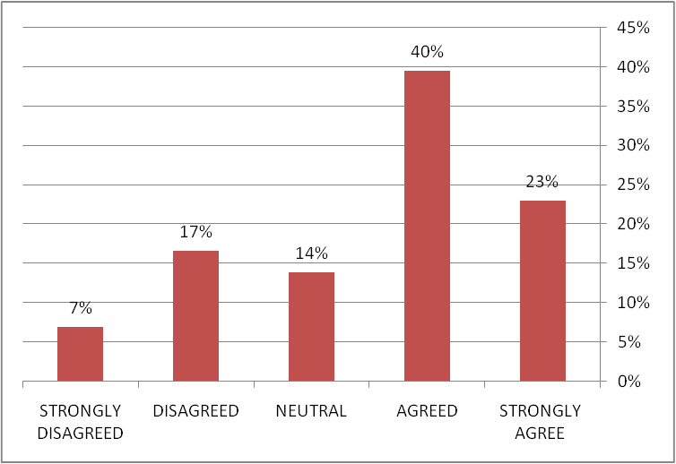
Figure (1): Manipulating images leads to loss of credibility (Source: Primary Survey)

The second question enquired respondents’ psychological thought process by asking the following question: Will you feel reprimand for posting a heavily manipulated photograph which is praised by the public for your photography skills. Figure 2 illustrates that 75% of respondents agreed with this statement (62 strongly agree, 79 agreed). The score of median four and mean value 3.88 indicates that an unethical photo manipulation is a guilt-ridden act for photographers. It doesn’t matter that this act will make their work popular and praise in public.

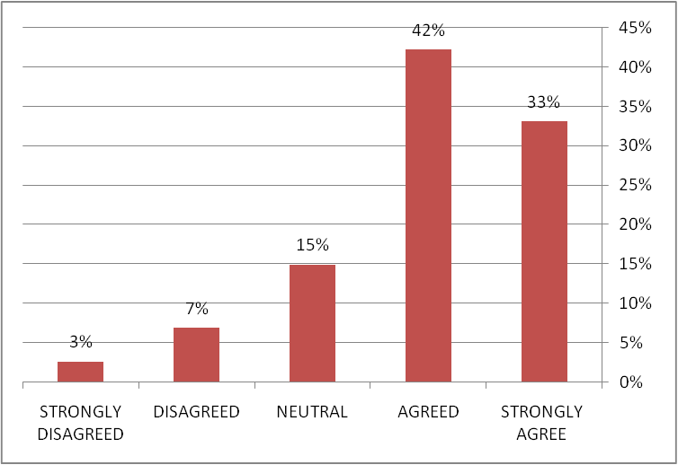
Figure (2): Feeling reprimanded for posting a photo that has been manipulated (Source: Primary Survey)

Figure 3 represents the third question response in informing viewers about the presence of photo manipulation. The results indicate a general trend towards the need to inform the public of the presence of image manipulation (62%). Despite this approach, 19% of the respondents oppose this matter, and 10% chose to remain neutral.

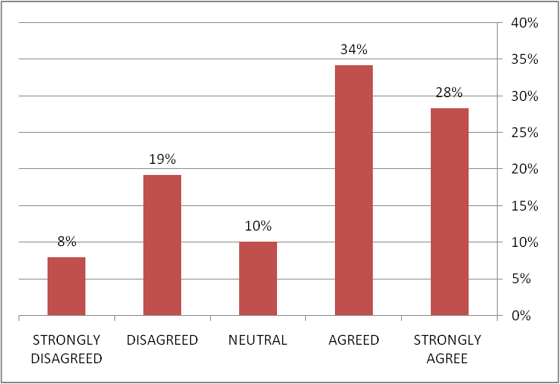
Figure (3): Informing viewers about the presence of photo manipulation (Source: Primary Survey)
As for the fourth question, the majority of respondents (75%) agreed on the necessity to apply ethics and guidelines for dealing with images when participating in contests or posting photos in the media or social networking sites, as shown in Figure 4. Respondents strongly supported this statement (Median:4.5, Mean: 4.01, StdDev: 1.25).
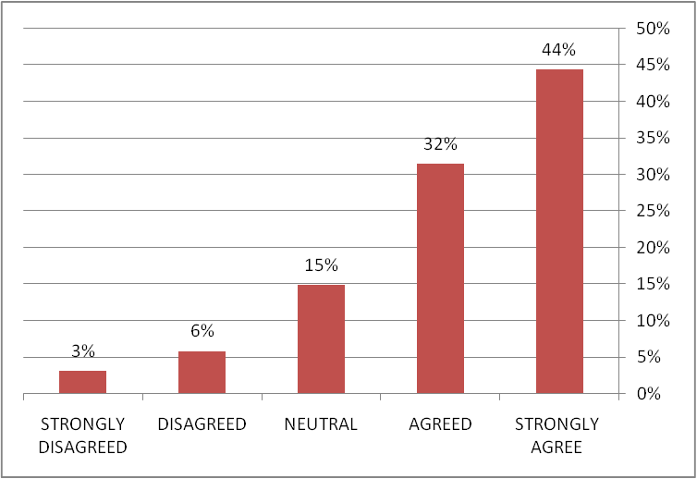
Figure 4: Applying ethics and guidelines for dealing with images (Source: Primary Survey)

The fifth question asked for their opinion about the application of photo manipulation ethics on all types of photography. The score of median three and a slightly higher mean of 3.26 indicates that respondents were not sure on this issue and opinion remained neutral. This result scored the largest standard deviation value of 1.27. Figure 5 shows the result of the respondents.

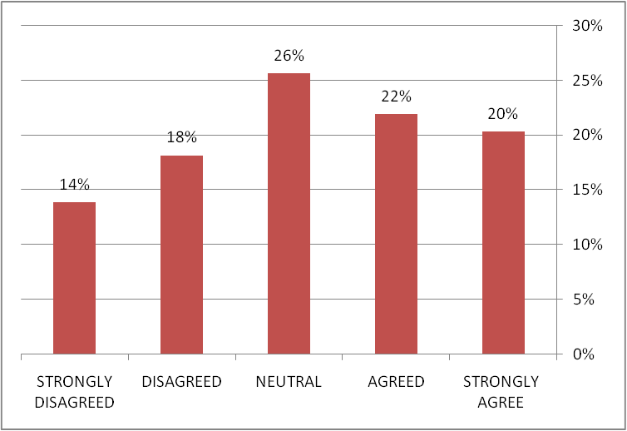
Figure (5): Application of photo manipulation ethics on all types of photography (Source: Primary Survey)
The sixth question enquired whether the respondents hate if a reputable photographer or organization was altering an image in an unethical way. Figure 6 depicts that 68% of respondents were in agreement with this statement. Responses were again inconsistency of previous results with a median of 4 and mean value of 3.97, which propose that photographers don’t approve unethical practices of photo manipulation; even if they are credited to reputed names or organizations in the photography community.
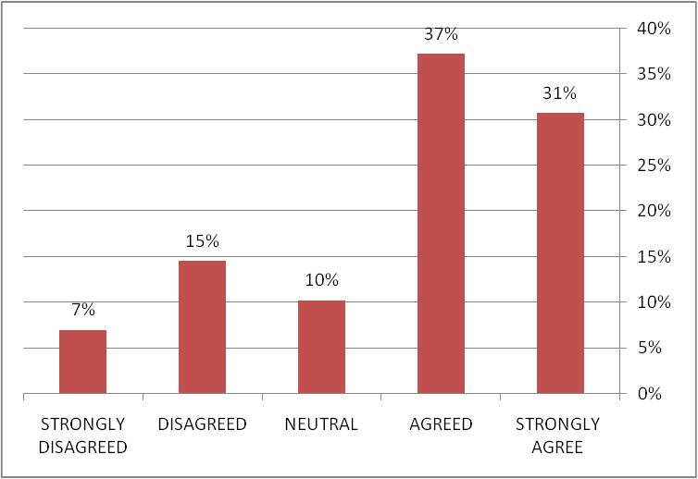
Figure (6): Those who do not accept a photographer or organization changing the photo in an unethical way (Source: Primary Survey)
The final question in this part that enquired about how photo manipulation is an increasingly important issue in photography society. As depicted in figure 7, a total of 84% of respondents agreed with this statement which suggests that photographers are concerned about the negative impact of photo manipulation.
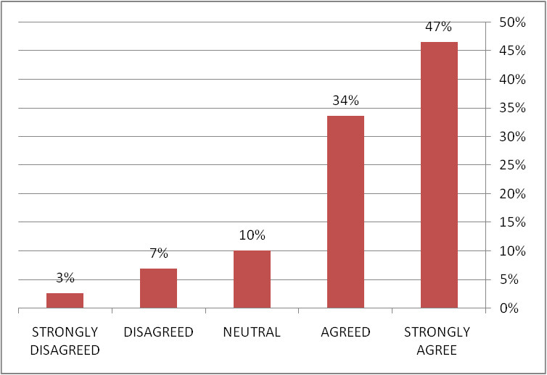
Figure (7): Photo manipulation is an increasingly important issue (Source: Primary Survey)
The second part of the survey was designed to enquire about respondents’ acceptance of various Photoshop techniques used in photo manipulation. The survey results indicate that photographers approved cropping, color correction and brightness-contrast adjustment as acceptable photo manipulation techniques in their professional ethics. As shown in table 1, the median score was 4 for each category and mean value was 4.01, 3.97 and 3.88, respectively. The majority of respondents were in agreement with these photo manipulation techniques in their professional ethics. Further, respondents gave their neutral response to other techniques like digitally altering depth of field, burning and dodging, and removing distracting elements. The median score was 3 for the above techniques and mean was 3.26, 3.03, and 2.9, respectively. Photographers were unsure about clearly putting them in a decisive category of ethical or unethical conduct. In the case of burning and dodging, this study is in coherence with Oriez (2009), who found that readers have a neutral response on burning and dodging. The results further revealed that cloning pixels was not supported among respondents as it acquired a median of 2 and a mean of 2.43.
Table (1): Mean Performance score of Survey Part 2
Photo manipulation technique | Median | Mean | StdDev
Digitally altering the depth of field | 3 | 3.26 | 1.27
Brightness contrast adjust | 4 | 3.88 | 1.15
Removing distracting elements | 3 | 2.90 | 1.31
Burning and dodging | 3 | 3.03 | 1.24
Color correction | 4 | 3.97 | 1.00
Cloning pixels | 2 | 2.43 | 1.19
Cropping | 4 | 4.01 | 1.25
(Source: Primary Survey)

With increasing cases of manipulated images, photojournalists are responsible for jeopardizing their credibility and integrity of photojournalism. By looking at the analysis of the opinion of the study sample (daily newspaper photographers, photographers of news websites, television channel photographers, and freelancer and media Students), and by conducting the ANOVA test, it is evident from Table (2) that the study sample believes that digital processing of images and making adjustments to them will lose the credibility of the image. This result confirms that it is necessary to apply ethics and guidelines for dealing with images when participating in contests or posting photos in the media or social networking sites.
Table (2) Analysis of Variance
 | t | Sig. (2-tailed) | Mean Difference | 95% Confidence Interval of the Difference
 |  |  |  | Lower | Upper
Loss of Credibility Due to digital image manipulation: daily newspaper photographers, photographers of news websites, and television channel photographers | 37.040 | .000 | 1.1690 | 1.107 | 1.231
Loss of credibility due to digital image manipulation: freelancer and media students | 33.586 | .000 | 1.3310 | 1.253 | 1.409

Discussion
The objective of this research was to evaluate the perception of digital manipulation by photographers on ethical grounds. In the survey, photographers agreed that photo manipulation is an increasingly important issue in today's photographic society. The outcome suggests that by recognizing this issue, the photography community have the desire to restore the integrity of photography. This outcome parallels the research that stated that the most critical issue faced by the media was the depletion of public credibility (Safori, 2018). The findings show that photographic manipulation is held responsible for depleting the credibility of photography by the photographic society. Photographers agreed to inform viewers about the presence of photo manipulation in their image, which indicates that transparency was supported by photographers, encouraging practices to restore photography credibility. This outcome strengthened Huang (2001), who said that awareness of the presence of photo manipulation plays a major role in the acceptance of digital imaging manipulation by readers. The result can be understood by this justification: like each photograph, the genre has its own set of ethics and rules that can not be imposed on other genres. Photographers from different genres also agreed that ethics should be followed while participating in the photography contest, which indicates that photo manipulation community characteristically prefer the regime of ethics and the rule of fair practices in the photography contest. Photographers accepted that they would feel guilty for being praised after posting a manipulated image on social media. This inherent guilt of the photography community lends evidence of increased visual ethics activism.
Message credibility impact is related to source credibility and the credibility cues given by these publications. Message credibility is defined as the believability of the message that is at the beginning told the audience, and it is most important when the source credibility is low. If the news source is brought in to-question, then the other cues will be looked more critically. Photographs present in a news story can be looked upon as the message.
The results of the second part of the survey revealed that photographers approved photo manipulation techniques like cropping, color correction, and brightness-contrast adjustment, which suggests that the above methods are considered acceptable by all photography genres. These findings are in line with what is found in the literature; attempts to digitally manipulate colours to achieve the desired hue are ethically acceptable by media professionals (Roux, 2019; Gladney& Ehrlich, 1996). Respondents were neutral about “burning and dodging” technique. This result differs significantly from responses of Shiela Reaves (1992). The possible reason behind this can be understood by the fact that Reaves’ subjects were shown example image of burning and dodging. Photographers mostly accept this technique; however, there are cases of taking it to such an extreme that has crossed the ethical line (Siegel, 2003). The survey received the neutral response for “removing distracting elements” and “digitally altering the depth of field”, which also slightly differs from results achieved by Reaves (1992) and Thompson (2006) in their survey of photojournalists. Their subjects disagreed with this practice. The possible reason behind this disapproval is the strict conduct of ethical code in journalism. Finally, the cloning of pixel was disapproved in the survey, which supports the earlier study of Oriez (2009), who proved that adding or removing people is disliked by readers and got a median score of 2.

Conclusion
In this survey, the negative impact of photo manipulation on photography was recognized by the photography society, which is a positive sign of the willingness of photographers to curb unethical photo manipulation practices and maintain the integrity of the image. Photographers from all professions were worried about the depletion of the credibility of photography and agreed to reinstate the requirements for ethical behaviour in photography. Some techniques of photo manipulation, such as cropping, colour correction, and brightness adjustment have been accepted by professionals. The argument can be made that these manipulations do not spoil the integrity of the image. Nevertheless, those manipulations that can potentially reduce the image truth, such as cloning, removing distracting elements, may be not acceptable, or photographers have obtained a neutral or hesitant response.
The newspaper industry is built on the credibility of its publications. When a reader looks at a news source, the mind begins looking for cues on whether the article is to be trusted or not. These cues vary from a load time of an online page to spelling to the sources interviewed. If the cues check out, then the reader may be more likely to trust that source. If the reader questions the cues, then the article will be questioned and might be dismissed completely. Photographs are an important part of the news because they are rapidly evaluated visually and trigger an emotional response that draws the reader into the photograph and story. This physiological response essentially determines how the reader perceives the message.
Overall, it is worth considering a few limitations of this study. By including more professional organisations and professional photographers, the scope of this study could have been more decisive and influential. In shaping the conclusion and getting a more precise perception of the photographic society, more experienced opinions would have been allowed.

References
Al-Mashhadani, S. (2017). Media Research Methods. University Book House, Al Ain, UAE.
Brantner, C., Lobinger, K. & Wetzstein, I. (2011). Effects of visual framing on emotional responses and evaluations of news stories about the Gaza conflict 2009. Journalism & Mass Communication Quarterly, 88(3), 523-540.‏
Callaghan, K. & Schnell, F. (2009). Who says what to whom: Why messengers and citizen be- lief matter in social policy framing. The Social Science Journal, 4612-28.
Campbell, D. (2014). The integrity of the image. Report of the World Press Photo Academy. Available at: www.worldpressphoto.org/sites/default/files/upload/Integrity% 20of% 20the% 20Image_2014% 20Campbell% 20report. pdf. (accessed Jun 2020)
Gladney, G. & Ehrlich, M. (1996), Cross-media response to digital manipulation of still and moving images, Journal of Broadcasting & Electronic Media. 40(4), 496-508.
Greer, J. & Gosen, J. (2002). How much is too much? assessing levels of digital alteration of factors in public perception of news media credibility. Visual Communication Quarterly. 9(3),4-13.
Huang, E. (2001). Readers' perception of digital alteration in photojournalism. Journalism & Communication Monographs 3(3):147-182.
Lester, P. (2018). Visual ethics: A guide for photographers, journalists, and filmmakers. Taylor & Francis.‏
Lowrey, W. (2003). Normative conflict in the newsroom: The case of digital photo manipulation. Journal of Mass Media Ethics. 18(2), 123-142.
Lowry, P., Wilson, D., & Haig, W. (2014). A picture is worth a thousand words: Source credibility theory applied to logo and website design for heightened credibility and consumer trust. International Journal of Human-Computer Interaction, 30(1), 63-93.
Mäenpää J, & Seppänen J (2010). Imaginary darkroom: Digital photo editing as a strategic ritual. Journalism Practice. 4(4), 454-475.
Mingoia, J., Hutchinson, A., Gleaves, D. & Wilson, C. (2019). The relationship between posting and photo manipulation activities on social networking sites and internalization of a tanned ideal among Australian adolescents and young adults. Social Media+ Society, 5(1), 2056305118820419.‏
Mortensen, T. & Gade, P. (2018). Does photojournalism matter? News image content and presentation in the Middletown (NY) Times Herald-Record before and after layoffs of the photojournalism staff. Journalism & Mass Communication Quarterly, 95(4), 990-1010.‏
National Press Photographers Association. (2004). NPPA board adopts new modernized code of ethics. Available at:
www.nppa.org/newsandevents/news/2004/07/. (accessed Jun 2020)
Oriez, R. (2009). Do readers believe what they see?: reader acceptance of image manipulation. PhD Thesis, University of Missouri, Columbia.
Quinn, A. (2003). Accepting manipulation or manipulating what's acceptable?. In Selected papers from the conference on Computers and philosophy Australian Computer Society, Inc. Volume 37: 59-64.
Reaves, S. (1992). What's wrong with this picture? Daily newspaper photo editors' attitudes and their tolerance toward digital manipulation. Newspaper research journal . 13(4): 131.
Reaves, S. (1995). The vulnerable image: Categories of photos as a predictor of digital manipulation. Journalism & mass communication quarterly. 72(3): 706-715.
Ritchin, F. (1990). Photojournalism in the age of computers. The critical image: essays on contemporary photography. 35-36.
Roux, C. (2019). Ethical considerations in digital photo manipulation and editing.‏ Master thesis, Department of Telecommunications, Ball State University, USA
Safori, A. (2018). Social Media's Impact on a Journalist's role. Journal of Science Education, 19(1), 148-62.‏
Saleh, H. (2016). Developing new media credibility scale: A multidimensional perspective. International Journal of Social, Behavioral, Educational, Economic, Business and Industrial Engineering, 10(4), 1287-1300.
Self, C. (2009). Credibility. In D. W. Stacks & M. B. Salwen (Eds.), An integrated approach to communication theory and research (2nd Ed.). New York and London: Routledge.
Sharma, J. & Sharma, R. (2017). Analysis of key photo manipulation cases andtheir impact on photography. The IISU-JOA Journal of Arts, 88-99.‏
Siegel, R. (2003). Interview: Patrick Schneider discusses the ethics of traditional photo-altering techniques in news photography [Radio series episode]. All Things Considered.
Silva, M. & Eldridge II, S. (2020). The Ethics of Photojournalism in the Digital Age. Routledge.‏
Society of Professional Journalists. (1996). Society of Professional Journalists: Code of Ethics. Society of Professional Journalists.
Thompson, B. (2006). A snapshot of photojournalists' attitudes toward the ethics of digital manipulation”. unpublished paper presented to the Association for Education in Journalism and Mass Communication, San Francisco.
Thompson, E. (2017). Legal and ethical considerations for digital recreations of cultural heritage. Chap. L. Rev., 20, 153.‏
Wheeler, T. (2002). Photofiction or photo truth? Ethics and Media Imagery in the Digital Age.
Winslow, D. (2005). Three entries in WHNPA Eyes of History 2005 contest lead to new guidelines; Andrea Bruce Woodall is POY again. Available at: https://nppa.org/news/272. (accessed Jun 2020)
Yao, QQ, Perlmutter, D.D. and Liu, J.Z., (2017). What are shaping the ethical bottom line?: Identifying factors influencing young readers’ acceptance of digital news photo alteration. Telematics and Informatics. 34(1), 124-132.
Xu, Q. (2013). Social recommendation, source credibility, and recency: Effects of news cues in a social bookmarking website. Journalism & Mass Communication Quarterly, 90(4), 757- 775.

Faculty Media, Zerga University, Jordan. Received: 19/11/2020. Accepted: 28/2/2021. © All copyrights reserved for Ata University, Karak, Hashemite Kingdom of Jordan, 2023.
كلية الإعلام، جامعة الزرقاء، الأردن. تاريخ تقديم البحث: 19/11/2020. تاريخ قبول البحث: 28/2/2021م . © جميع حقوق النشر محفوظة لجامعة مؤتة، الكرك، المملكة الأردنية الهاشمية، 2023 م.

